ELP H.264 USB Camera
This article describes how to use a VLC player to decode the camera's H264 video stream to achieve preview.
This feature is limited to desktop Linux systems (such as Ubuntu) and the kernel version must be higher than Linux 3.0. This article uses ubuntu12.04 system for demonstration.
Insert the H.264 camera, you can see two new video devices: video0 and video1 in the dev directory. If there are other video devices on this machine, the last two are the main ones.
Among them, video0 is the YUV, MJPEG data channel, and video1 is the H264 data channel, which is the device used for decoding preview in this article.
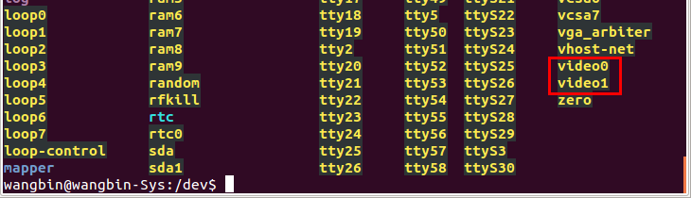

Install the VLC player first, search for "VLC" in the "Software Center", and then install.
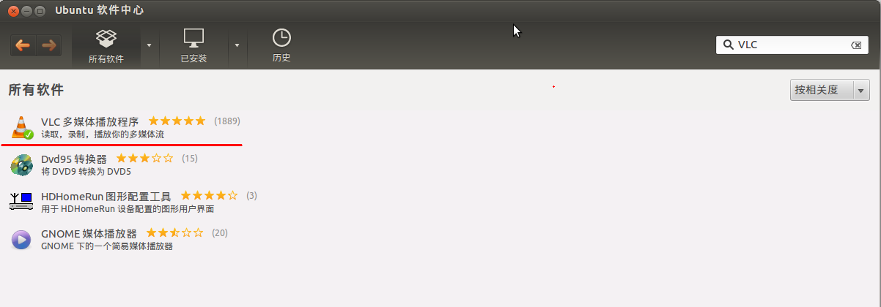

Open VLC software and select "Open Capture Device" in the "Media" menu
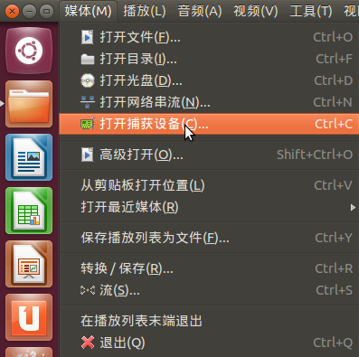

Capture mode is Video for Linux2 by default
Select /dev/video 1 in the device name, leave the others as default, and click “Play”
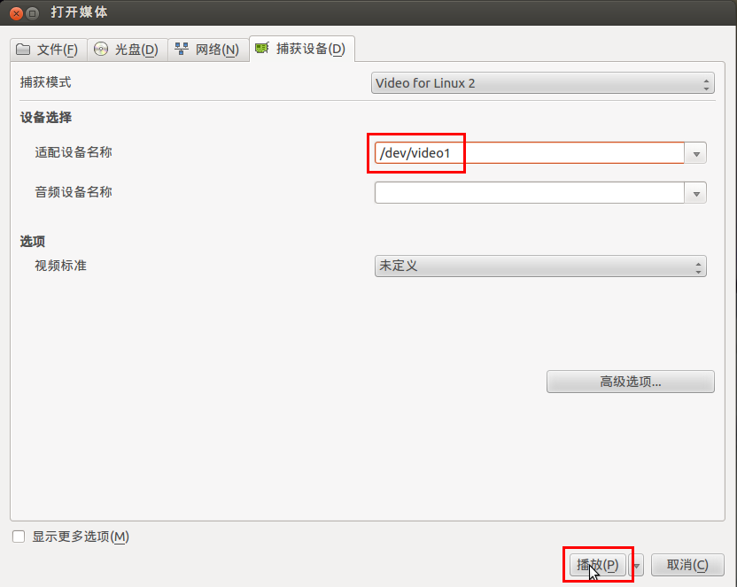
H.264 720P preview screen:
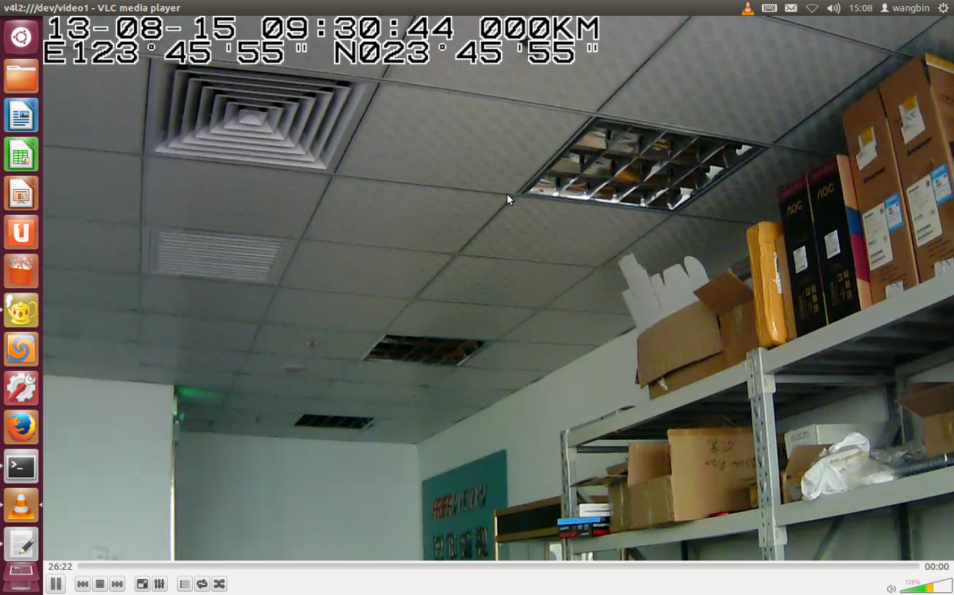

View decoding information:
